

**Walchand College Of Engineering, Sangli.**

**(An Autonomous Institute)**

**Department Of**

**Computer Science and Engineering**

**Mini-Project Synopsis**

on

**Parallel-O-Code**

### by

### Aditya Gadadhani (2018BTECS00034)

### Shreyas Mandade (2018BTECS00035)

### Abhishek More (2018BTECS00037)

### Under the Guidance of

### **Asst. Prof. Miss.P.D.Mundada**

### **Guide**

|  |
| --- |
| **Dr. M. A. Shah** |
| HOD |
| **Computer Science &Engg. Dept,** |
| **WCE, Sangli** |

### 2020-21

1. **Problem Statement:**

To provide the user with different set of standard algorithms written in accordance with parallelization in the field of coding algorithms and Image processing.

1. **Abstract:**

Whenever a technology evolves, what drives the creator to modify/renovate the existing technology?

The answer is quite simple-To make it more efficient.

Similarly, when we think of how to make our algorithm more efficient we think of reducing it's time complexity.

Therefore, we intend to develop an interface that provides solution to existing standard algorithms in the field of programing and image processing with the help of parallel computation.

We aim to modify C++ algorithm in the above fields with the help of OpenMP(The application programming interface that supports multi-platform shared-memory multiprocessing programming)

to reduce the time-complexity of standard algorithms.

Once the parallelized code is created, the user can use it in various ways, like:

1) In competitive programing.

2) To create a project that uses Image processing technique.

3) Advanced graphics, augmented reality and virtual reality.

4) Real time simulation of systems.

1. **Objective:**
2. Study of OpenMP to achieve best use of hardware with parallel programming in CPP.
3. Implementing the codes for widely used algorithms in regular way of serial programming and then same algorithms in parallel programming.
4. A study of image processing algorithms. Writing IP algorithms into CPP and converting serial code to efficient parallel code. Compare time taken in regular serial operations and parallel operations.
5. Design an web app based user interface to display achieved efficiency in time

through parallel programming.

1. **Outcomes:**

The web app web application based UI to compare time consumed in serial and parallel programming. Users will be able to execute codes and verify reduced time.

1. **Market Potentials:**
2. Can be utilized to run multiple tasks at the same time .
3. In the market, this platform can establish its reputation as an efficient, reliable and faster environment for conducting various image processing applications.
4. Can be used to make better work of hardware.
5. As many programs are carried out at same time, it will also save money.
6. **UML Diagram:**

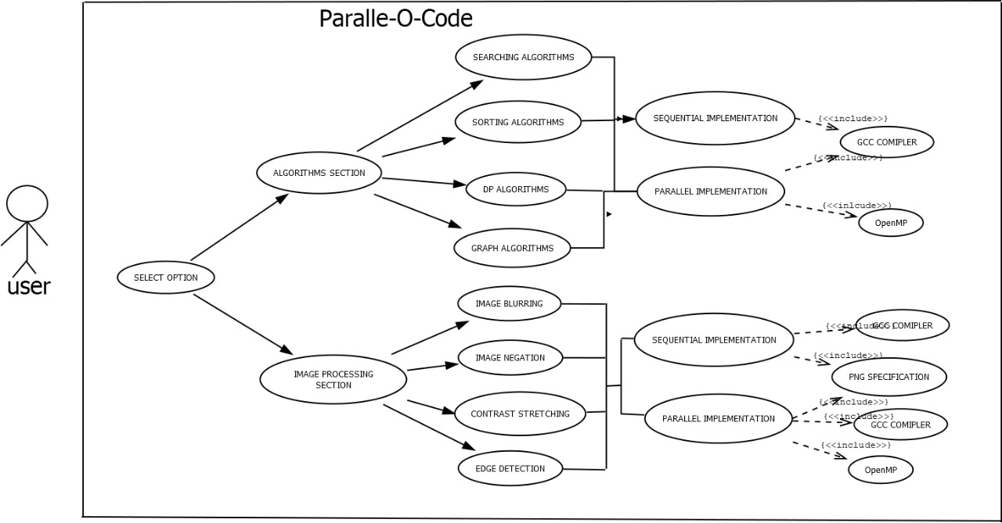

1. **Project Plan:**

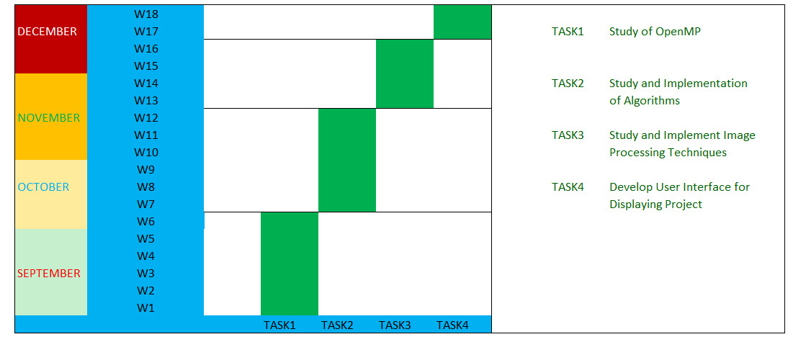

1. **Test Cases:**
2. Using of PNG library in C++ code within an compiler would be a challenging task.
3. Deciding number of threads to use in parallelized code would be a challenging task as for different number of thread different time is achieved.
4. Showing an image transition in an online viewing mode would be a difficult task.
5. Use of file handling in image processing operation to import (.png)

Images would be a difficult task.